**Practical 1:**

**Aim: - Write a program to accept a string and validate using NFA.**

**Theory: -**

NFA stands for *non-deterministic finite automata.*

To understand NFA we first look at what is an Automata.

The term "*Automata*" is derived from the Greek word "*αὐτόματα*" which means "*self-acting*". An automaton (Automata in plural) is an abstract self-propelled computing device which follows a predetermined sequence of operations automatically.

An automaton with a finite number of states is called a **Finite Automaton** (FA) or **Finite State Machine** (FSM).

**Formal definition of a Finite Automaton**

An automaton can be represented by a 5-tuple (Q, ∑, δ, q0, F), where −

* **Q** is a finite set of states.
* **∑** is a finite set of symbols, called the **alphabet** of the automaton.
* **δ** is the transition function.
* **q0** is the initial state from where any input is processed (q0 ∈ Q).
* **F** is a set of final state/states of Q (F ⊆ Q).

**NFA:-**

The finite automata are called NFA when there exist many paths for specific input from the current state to the next state. Every NFA is not DFA, but each NFA can be translated into DFA. NFA is defined in the same way as DFA but with the following two exceptions, it contains multiple next states, and it contains ε transition.

**Example**:-

In the following image, we can see that from state q0 for input a, there are two next states q1 and q2, similarly, from q0 for input b, the next states are q0 and q1. Thus it is not fixed or determined that with a particular input where to go next. Hence this FA is called non-deterministic finite automata.

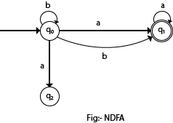

## **Formal definition of NFA:**

NFA also has five states same as DFA, but with different transition function, as shown follows:

**δ: Q x ∑ →2Q**

where,

1. Q: finite set of states
2. ∑: finite set of the input symbol
3. q0: initial state
4. F: **final** state
5. δ: Transition function

## **Graphical Representation of an NFA**

An NFA can be represented by digraphs called state diagram. In which:

1. The state is represented by vertices.
2. The arc labeled with an input character show the transitions.
3. The initial state is marked with an arrow.
4. The final state is denoted by the double circle.

**Example 1**:-

1. Q = {q0, q1, q2}
2. ∑ = {0, 1}
3. q0 = {q0}
4. F = {q2}

**Solution:**

Transition diagram:

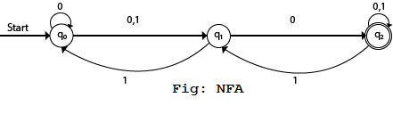

Transition Table:

|  |  |  |
| --- | --- | --- |
| Present State | Next state for Input 0 | Next State of Input 1 |
| →q0 | q0, q1 | q1 |
| q1 | q2 | q0 |
| *q2 | q2 | q1, q2 |

In the above diagram, we can see that when the current state is q0, on input 0, the next state will be q0 or q1, and on 1 input the next state will be q1. When the current state is q1, on input 0 the next state will be q2 and on 1 input, the next state will be q0. When the current state is q2, on 0 input the next state is q2, and on 1 input the next state will be q1 or q2.

### Example 2:

NFA with ∑ = {0, 1} accepts all strings with 01.

**Solution:**

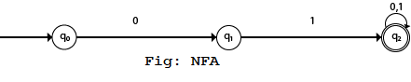

Transition Table:

|  |  |  |
| --- | --- | --- |
| Present State | Next state for Input 0 | Next State of Input 1 |
| →q0 | q1 | ε |
| q1 | ε | q2 |
| *q2 | q2 | q2 |

### Example 3:

NFA with ∑ = {0, 1} and accept all string of length atleast 2.

**Solution:**

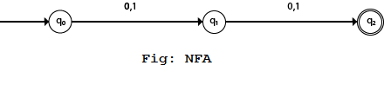

Transition Table:

|  |  |  |
| --- | --- | --- |
| Present State | Next state for Input 0 | Next State of Input 1 |
| →q0 | q1 | q1 |
| q1 | q2 | q2 |
| *q2 | ε | ε |

# **Implement NFA algorithm (based on Python)**

Ideas for solving problems

Design of data structure

Referring to the definition of NFA, NFA is a 5-tuple: M = (Q, ∑, Δ, s, F)

Where: Q is the finite set of states

   Σ is a finite alphabet

   s is the start state

   F contained in Q, end state set

  Δ Set of state transition functions

**Solution algorithm:**

NFA identification string: there are many possible paths for a string to pass through the NFA. As long as there is one that can finally reach the end state, the NFA can identify the string. Therefore, just get the set of states that the string finally reaches through the NFA and check whether there is an end state. If it exists, NFA can recognize this string, otherwise it cannot.

We should also consider the problem of empty character e, the set of states that a state can reach through empty character e, that is, the problem of empty closure of a state needs to be considered. If I is a subset of a set of States, I will have an empty closure set, which is recorded as ε- closure(I). The empty closure set is also a state set, and its elements conform to the following points: all elements of I are elements of the empty closure set; For each element in I, start from that element and pass through any bar ε The states that an arc can reach are elements of an empty closure set.

* In class NFA, four functions are designed, which are read_string()，e_closure()，next_state()，match_final_state().
* Function read_string(input_str): read the input string and judge whether it can be accepted by NFA
* Function e_closure(state): find the empty closure of a state (the idea of BFS)
* Function next_state(current_states, c): the next state set reached by the current state set through the character C
* Function match_final_state(final_current_states): the final state matches the accepted state

**Code**:-

"""Design to recognize strings NFA"""

import string

from collections import deque

class NFA:

def __init__(self, states, symbols, t_state, start_state, final_state): # initialization

self.states = states # State set

self.symbols = symbols # Input symbol set / alphabet

self.t_state = t_state # State transition function

self.start_state = start_state # Start state

self.final_state = final_state # End state

# The collection of the next state that the

# current state can reach through a character, including empty closures

def next_state(self, current_states, c):

# The next state set, including the set of empty closures of the next state set

next_states = []

for state in current_states:

if state in self.t_state.keys():

if c in self.t_state[state].keys():

n_states = self.t_state[state][c]

for s in n_states: # Gets the empty closure of the next state set

s_closure = self.e_closure(s)

# Add the set of empty closures to the next state set

for s_c in s_closure:

if s_c not in next_states:

next_states.append(s_c)

print('State transition:')

print(current_states, end=' ')

print('-' + c + '->', end=' ')

print(next_states)

# Returns the set of the next state obtained / the state set through the character c

return next_states

def e_closure(self, state): # Find the empty closure of a state

d_state = deque() # Dual ended queue, storing intermediate status

empty_bag = [] # Empty closure of a state

d_state.append(state)

empty_bag.append(state)

while (len(d_state)):

current_state = d_state[0]

if current_state in self.t_state.keys(): # If the current state exists

if 'e' in self.t_state[current_state].keys(): #If a null character transfer

for s in self.t_state[current_state]['e']:

if s not in empty_bag: # If the state is not in an empty closure

# Queue and join the state arrived via e into the empty closure

d_state.append(s)

empty_bag.append(s)

d_state.popleft() # Throw the current state

return empty_bag

 # The final state matches the end state

def match_final_state(self, final_current_states: list) ->bool :

for state in final_current_states:

if state in self.final_state:

return True

return False

def read_string(self, input_str): # Read string to enter NFA authentication

for c in input_str: # Judge whether the string meets the alphabet

if c not in self.symbols:

print('Illegal character in string')

return

next_states = [self.start_state]

for i in str:

next_states = self.next_state(next_states, i) #call

#print(next_states)

result = self.match_final_state(next_states) #call

if result == True:

print('NFA This string is acceptable')

else:

print('NFA The string cannot be received')

if __name__ == '__main__':

states = ['q1', 'q2', 'q3', 'q4'] # NFA state set

symbols = ['0', '1'] # NFA alphabet

t_state = {

'q1': {

'0': ['q1'],

'1': ['q1', 'q2']

},

'q2': {

'1': ['q3'],

'0': ['q3']

},

'q3': {

'1': ['q4']

},

'q4': {

'0': ['q4'],

'1': ['q4']

}

} # State transition function

start_state = 'q1' # Start state

final_state = ['q4'] # End state set

while True:

str = input("Please enter the test string:")

if str == 'exit':

break

nfa = NFA(states, symbols, t_state, start_state, final_state)

nfa.read_string(str)

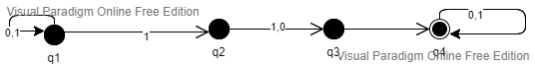

**Output:-**

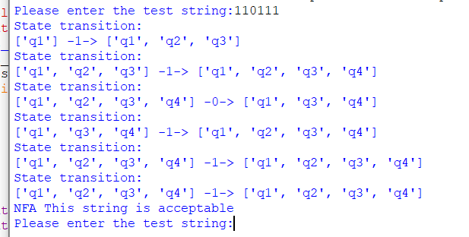

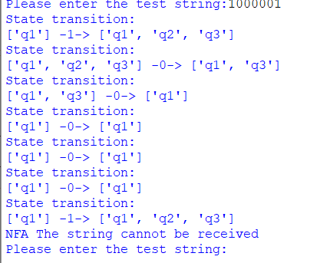

**Conclusion**:-

The entered string were identified as NFA or not based of the provided state diagram .